* Inhibition and control are required to make enzymes work only when required
* The active site of protein – enzyme
* Active vs remote site
* Regulation – allosteric effectors or chemical modifications
* Active site is where one or more substrate molecules bind for the protein to carry out its function – usually comprises only few residues from proteins – located far apart in aa sequence but close together when looking at 3D
* Mutating active site residue will completely destroy or modify E function
* Active site residues are localised to specific S binding pocket by folding of 3D structure – the entire folding process focuses on bringing the active site together for the chemical reaction to occur
* Complements the transition state in term of size, electrostatic, pH
* E binds both S and P but prefer the transition state – strongest binding affinity
* Serine proteases – 3 residues are critical for functions – histidine H57 H bonded to D102 and S195 – absolutely critical – enzymes in digestive system – trypsin, chymotrypsin and elastase – if stretch out will see 50 residues away between H57 and D102 and 100 residues for the 2 – but very close together when 3D- Histidine acts as base under physiological conditions
* Chymotrypsin cuts protein chain after aromatic residue – aromatic residue that can fit into substrate specificity pocket
* Reaction mechanism won’t be tested – while the residues may form bonds with solvent or the substrate – the E will be regenerated and take another S
* Mutating any of the residue may destroy or decrease the functions of E
* The active site of E is a completely different environment to the surrounding solution – it can be more acidic or basic by the positioning of the charged residues in the pocket – can provide hydrophobic environment – the S can only get into the pocket and fit into certain direction – make it stereospecific – only particular reactions can occur – electrophilic or nucleophlic functionality groups
* If we know the exact structure of the active site – can design inhibitor in biotech
* Enzyme inhibitors are designed bases on active site
* Atorvastatin – bound to coenzyme HMG – lowering cholesterol
* Development of drugs progress because of kinetic and structure study of the enzyme (the ones we studied last lecture, equations)
* Two classes of enzyme inhibitors
  + Reversible inhibitors – noncovalent bond
  + Irreversible inhibitors – covalent bond
* ES reaction
  + E + S forms ES and then form E + P
  + P doesn’t go back and form E + S
  + Delta G support direction of toward P
  + Inhibitors bind active site and prevent E from binding OR bind somewhere else and change the shape of the S
  + E + I then EI then no products
* Reversible inhibition
  + Many drugs follow this
  + 3 types – competitive, uncompetitive, non-competitive or mixed – different modes of activities
* Competitive inhibition – inhibitor blocks the pocket of the active site – substrate cannot bind so no get products – S can be processed but I cannot
  + In the absence of I – will follow hyperbolic curve in blue – reaction proceeds well even with little S
  + When add I – it competes with S to get to the active site – has good chance of getting to active site before S – slowing down the reaction – shape of curve doesn’t change but rising very slower – the curve moves down
  + 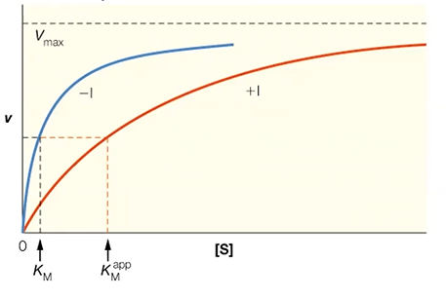
  + In straight line plot, add I, rate of reaction goes down, slope increases – getting less product – KM increases a bit – vmax remains constant
  + Km increases so need more S to get to the same rate
  + Slope changes but intercept does not change – where it cuts the x-axis changes
  + 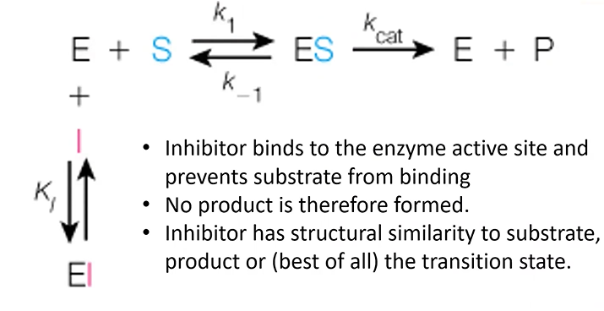
  + Examples: (common questions) methanol poisoning, ethanol and methanol complete for the same action site – can cause blindness – when people drink unrefined wine – methanol forms formaldehyde - treatment is to give ethanol – when ethanol is bound, methanol is removed from the body harmlessly
  + FQA – use ethanol to treat methanol poisoning
  + Malonate competitively inhibits succinate dehydrogenase – S is succinate – P is fumarate – I is very similar to S – malonate binds to active site and stop succinate from binding
  + Drugs are designed to fit active site – eg. oseltamivir – Avian Flu – fit enzyme pocket very well – control spread of the virus
  + Cancers can be treated by I – if we prevent adenosine being processed to inosine
  + HIV enzyme inhibitors
  + ACE inhibitors – angiotensin I causes high blood pressure and vasoconstriction – cut by ACE at the proline – forming angiotensin II – prevent congestive heart failure – captopril binds strongly with the enzyme (nm) while angiotensin I is um
* Uncompetitive inhibition
  + Does not bind to active site – not compete with S – S binds
  + As S binds, I bind at the regulatory site –sit far from active site – shape of E modified – active site cannot make P
  + So bind after ES forms but prevent P formation
  + Called Dead-end complex – E is neutralised – just go to corner and wait until I go or stuck there forever
  + Normal way to prevent E from functioning – reduce S in the circulation
  + 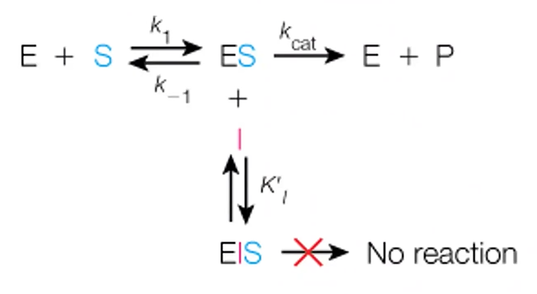
  + EIS – enzyme inhibitor substrate complex
  + Graph does not reach vmax – both vmax and kmax change
  + Vmax is affected more
  + Km shifts because vm shifts
  + With inhibitors, curve goes up – form parallel lines –simply move upward as more I
  + Slope remains the same but Km and Vmax decrease
  + 1 / [S] is increasing
  + 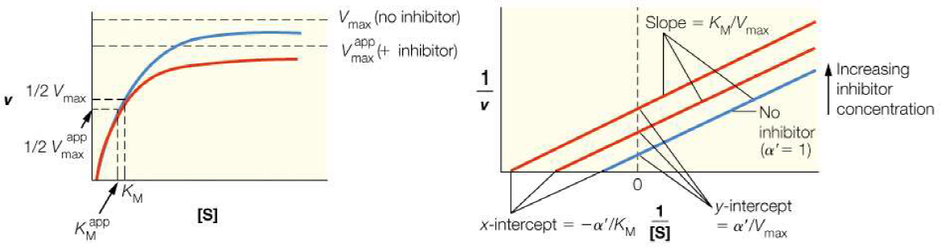
  + Example: anticancer drug methotrexate – green is the enzyme – black is the drug molecule methotrexate – cofactor in purple – when I bind after S is bound – S is cofactor – no product forms – I is sitting where S would bound
* Mixed or noncompetitive inhibition
  + I bind either to E directly or ES complex
  + It does not compete for active site
  + No P forms
  + Effect of vmax is more than effect on Km
  + Km has only small changes – almost the same
  + Vmax is decreased
* 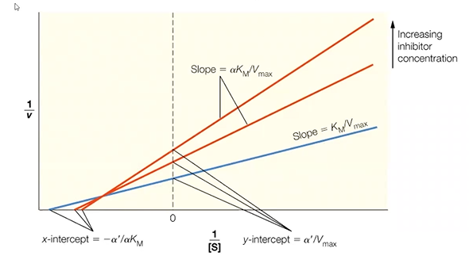
* Irreversible inhibition – cause rapid paralysis
  + Eg. I prevent molecule from conducting nerve conduction – DFP binds to the active site serine of acetylcholinesterase – form covalent bond with Serine – releasing HF – HF itself is toxic
* Enzyme regulation is very important – how much E is present – speed or slow it down – can be done at 3 levels
  + Gene level control – multiple isomeric forms called isozymes
  + Faster – allosteric mechansims – structural changes
  + Covalent modification – serious changes caused by forming covalent bond – usually phosphorylation or dephosphorylation – on or off switches
* Isozymes - LDH is at the end of sugar – different forms are created and form tetramers (quaternary structure) – see different forms in different cell types – regulating by making different mixes of this E (isozyme)
* Production of different enzymes – have different E activity – different E population provides different regulation and rate – can lead to diff products being formed – pathway becomes deviated leading to diff sets of products
* Allosteric control – final product actually controls the activity of the E in the very first step
  + Eg. ATCase – when have sufficient amount of CTP – it inhibits ATCase in the first step – when it is low, reaction happens again
  + Quick and efficient way – change from hyperbolic to sigmoidal – can be in positive or negative direction
  + ATP is positive effector – CTP is negative
* Reversible Covalent modification – phosphorylation, acetylation, etc. – covalent modification to control protein activity – post-translation of aa
  + Phosphorylation is most important – carried out by protein kinases – attaching phosphate to OH – converated to PO3 – need ATP – P is also provided by ATP – switches on E
  + Switch off – phosphatase removes P and generate E with OH (original state)
  + ATP is phosphate donor
  + A lot of activating signals
* Enzyme mechanisms
  + Fischer in 1894 think of E as locks – unlocked by S – bound together because of shape complimentary
  + Allosteric modification – lead to induced fit model – when S binds to E – they both adjust to fit each other – slight medication leading to transition state – when P released E goes back to original state
  + Structure of proteins – real shift when S binds and no bind – eg. hexokinase when glucose binds the enzyme change shape to sort of hug the glucose